sayandh sajeev

BlinkIT Grocery Sales Dataset

**1. Objective**

The main objective of this project is to analyze BlinkIT grocery sales data and gain insights into product performance and outlet performance. By building dashboards in Tableau, we want to understand:

* Which products sell the most
* How fat content and visibility affect sales
* Which outlets perform better based on size, type, and location
* Trends over time for outlet sales

This analysis will help in improving decision-making, optimizing product placement, and identifying growth opportunities.

**2. Problem Statement**

BlinkIT, like many grocery retail companies, faces challenges in:

* Identifying **which products drive the most revenue**
* Comparing **outlet sales performance** across different regions and outlet types
* Understanding the role of **item visibility, fat content** in driving sales
* Finding the **best and worst performing outlets**

Without proper insights, the company may lose revenue opportunities and fail to target the right customers effectively.

**3. Information About the Dataset**

The dataset contains information about grocery items and their sales across multiple BlinkIT outlets.

Key Columns:

* Item_Identifier → Unique ID for each product
* Item_Weight (Kg) → Weight of the product
* Item_Fat_Content → Fat category (Low Fat, Regular, etc.)
* Item_Visibility (%) → % of display space allocated to the product
* Item_Type → Category of the product (Dairy, Soft Drinks, Meat, etc.)
* Outlet_Identifier → Unique ID for each outlet
* Outlet_Establishment_Year → Year outlet was opened
* Outlet_Size → Size of the outlet (Small, Medium, High)
* Outlet_Location_Type → Location category (Tier 1, Tier 2, Tier 3)
* Outlet_Type → Type of outlet (Grocery Store, Supermar+ket Type1/2/3)
* Item_Outlet_Sales (₹) → Total sales value for an item in a specific outlet

**4. Data Cleaning Process (using Power Query in Excel)**

Before analysis, the dataset needs to be cleaned to remove inconsistencies:

1. **Remove Duplicates** → Check if there are duplicate rows for the same Item + Outlet.
2. **Handle Missing Values** → Fill or remove missing values in Item_Weight and Outlet_Size.
3. **Standardize Categories** → For example, Item_Fat_Content sometimes appears as LF, low fat, Low Fat. Standardize them into proper categories like Low Fat and Regular.
4. **Check Data Types** → Ensure numbers like Item_Weight, and Item_Outlet_Sales are numeric, while Item_Type, Outlet_Type remain text.

**Dashboard 1: Sales and Product Insights**

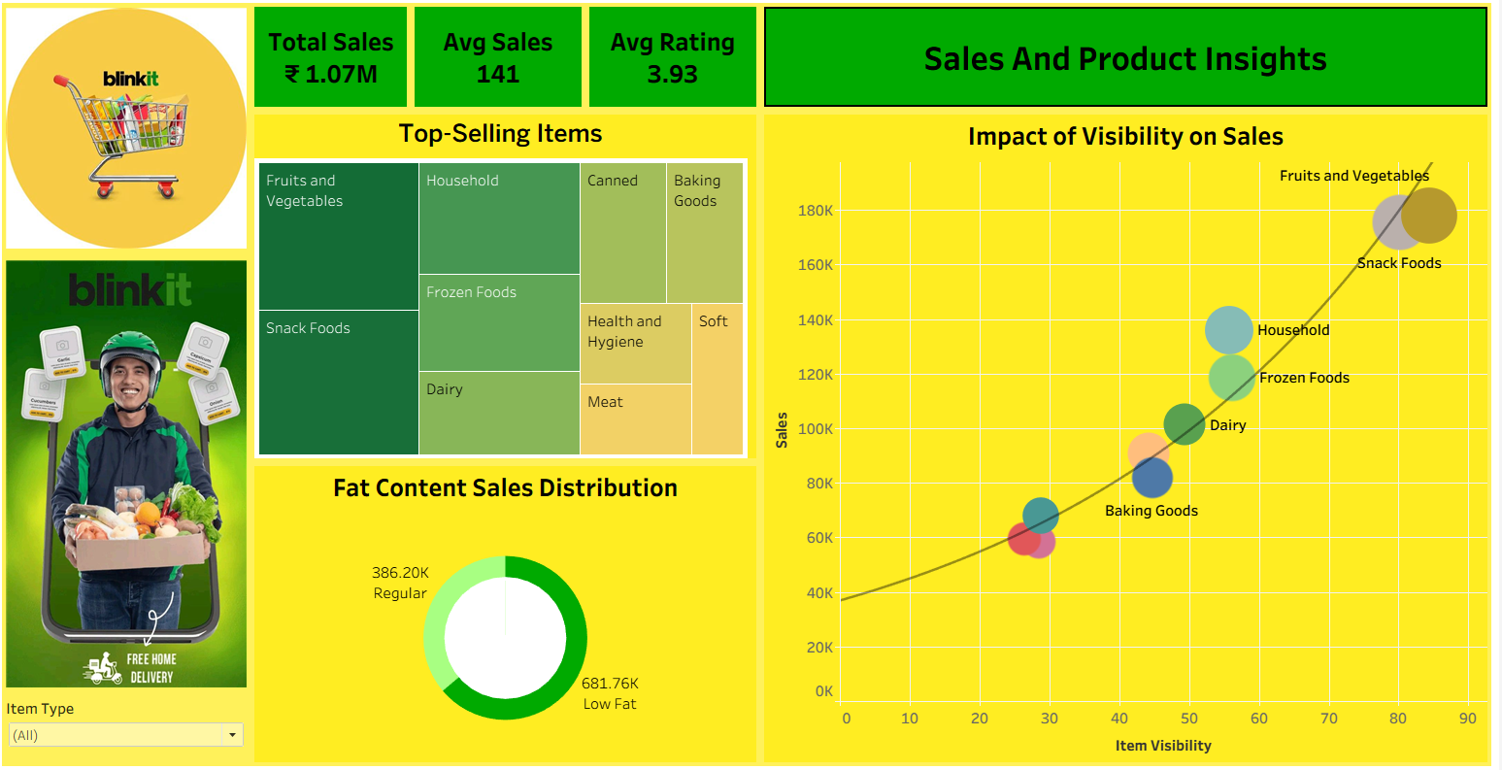

* **Performance Overview:** The total sales stand at ₹1.07M with an average sales figure of 141 and an average rating of 3.93, reflecting healthy consumer engagement.
* **Top-Selling Items:** Fruits & Vegetables and Snack Foods dominate sales, followed by Household, Frozen Foods, and Dairy. Categories like Soft Drinks, Meat, and Health & Hygiene contribute less comparatively.
* **Fat Content Analysis:** Low-Fat products (₹681.76K) significantly outperform Regular products (₹386.20K), suggesting a strong consumer inclination toward healthier options.
* **Visibility Impact:** Sales strongly correlate with visibility. Fruits & Vegetables and Snack Foods benefit most from higher visibility, whereas Baking Goods and Dairy, despite potential, show relatively lower traction due to less visibility.

**Dashboard 2: Outlet Performance Insights**

* **Bestsellers:** Fruits & Vegetables and Snack Foods are the best-performing categories across outlets, reaffirming findings from Dashboard 1.
* **Trends by Year:** Sales peaked in 2018 (~₹182K) but remained steady afterward around ₹115K–₹118K, showing potential saturation or limited growth post-peak.
* **Outlet Sales Performance:** Supermarket Type 1 is the leading format, generating over ₹600K sales, whereas Grocery Stores and other supermarket types underperform significantly.
* **Outlet-wise Sales Insights:** High and Medium-size outlets perform nearly equally well (₹600K each), while small outlets lag behind.
* **Geographic Insights:** Tier 3 cities (₹419K) outperform Tier 2 (₹349K) and Tier 1 (₹299K), indicating stronger adoption and higher sales potential in emerging markets.

**Overall Recommendations**

* Improve visibility of medium-selling categories (like Dairy and Baking Goods).
* Expand more in Tier 3 cities and support Tier 2 cities for steady growth.
* Strengthen Supermarket Type 1 (main sales driver).
* Improve smaller outlets and Grocery Stores with promotions.
* Focus on health trends (low-fat and healthy products).
* Launch new products, seasonal offers, and partnerships to boost growth after 2018 slowdown.

**Conclusion**

The analysis shows that Fruits & Vegetables and Snack Foods drive most sales, while visibility and health trends strongly influence customer choices. Supermarket Type 1 outlets and Tier 3 locations perform best, but smaller outlets and Tier 1 markets still have room to grow. By improving product visibility, expanding into new areas, and focusing on healthy options, Blinkit can grow steadily and balance its sales in the future.